|  |  |  |  |
| --- | --- | --- | --- |
| Name |  | |  |
| Score | / 10 |  |  |
| Update Value | |  |  |
| Make all corrections and resubmit to earn update points | | | |

Web Programming & RDD

152-150 152-156

# Installing PortableApps

10 points

Overview

In order to do web development you’ll need access to web development tools, a web server and a web-based database. As students you’ll need tools that are portable so you can use them at home and at school. PortableApps is the solution we’ll use. This lab will guide in the installation of PortableApps.

1. Insert your USB drive. Though I recommend you have dedicated USB drive for PortableApps you can install PortableApps on an existing drive.
2. Go to [www.portableapps.com](http://www.portableapps.com)
3. Click the Download button to download the PortableApps platform. The platform is basically a menu system that manages your PortableApps.  
     
   For all the downloads in this lab, I recommend you download the installation program to your desktop hard drive. This will speed up the installation process somewhat. If you download the installation file to your USB drive you’ll be able to install, but the process will be somewhat slower.
4. Launch the platform installer. When prompted to provide the location of PortableApps, be sure to select your USB drive.   
     
   You should install PortableApps in the *root* directory of your USB drive (e.g. E:\ or F:\). You can install PortableApps in a subfolder (E:\Web Programming) but I don’t recommend it and if you do, you may have to adjust the remaining steps in this lab.
5. 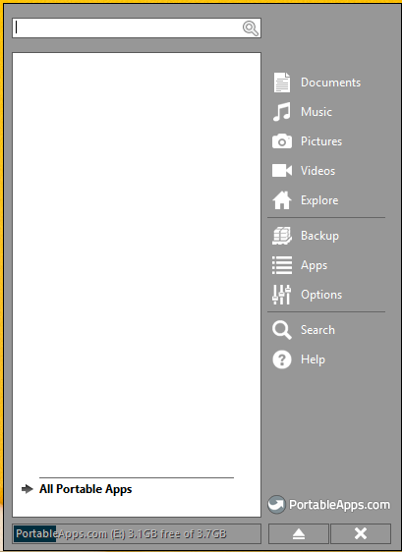When the install is complete, leave the *Run PortableApps Platform* option checked and click Finish.  
     
   The PortableApps menu will appear. PortableApps will sense that you don’t have any apps installed and will automatically go looking for them.
6. 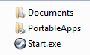Open Windows Explorer to browse your USB drive. You should see two folders and a shortcut to the PortableApps program (Start). The PortableApps folder will contain all the files for the apps you install. The Documents folder provides a convenient place to put your documents to make them portable as well.
7. After a little while, PortableApps will show you a list of the apps that are available.  
   (You can redisplay this list later by clicking the Apps button in the PortableApps menu.)  
   (You can also download apps from the portableapps.com website: click Get Apps) 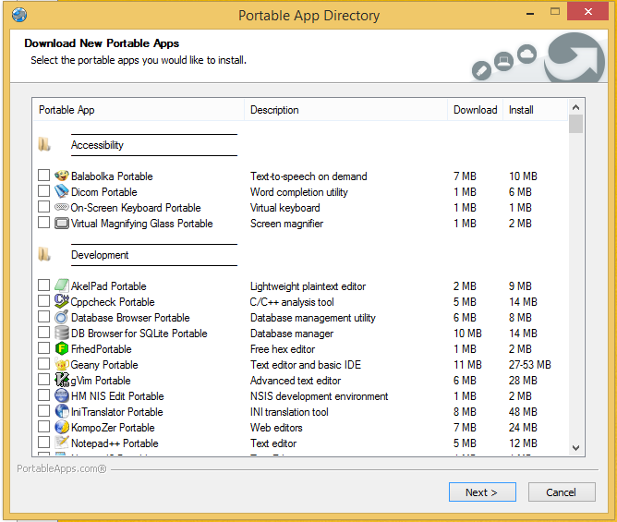
8. Scroll through the list and select the following apps:

* Notepad++ Portable (not really needed for RDD)
* XAMPP Launcher (not really needed for Web Prog  
   but you will need it for RDD)
* Google Chrome Portable (not needed for RDD)
* Mozilla Firefox, Portable (not needed for RDD, but handy)
* Opera, Portable (not need for either class, but handy)
* Feel free to include any other apps you may be interested in.

1. Click Next to download and install the apps you selected. Note that using the PortableApps menu button to get apps combines the download and install steps. If you go to the website to get apps, you’ll first have to download them, then install them.
2. After installation, open the PortableApps menu. You should see the apps you selected. Test one or two. Note: XAMPP Control Panel won’t work yet—there’s no XAMPP to control.

**Installing XAMPP**

XAMPP is a portable web server that lets you test server-side processing (PHP code) and server-based databases (MySQL) on your local computer before actually posting to the web. We’ll use this in RDD to practice SQL skills. We’ll also use these tools in Web Data Management to develop and test server-side processing of web pages and to test web pages that access MySQL databases.

1. You should have already installed the XAMPP Launcher in the first part of this lab. This app launches XAMPP, but didn’t install it.
2. Go to the class OneDrive folder. Download XAMPP Portable 1.8.3
3. After download is complete, unzip the zip file. You can save a step by **unzipping this file to the root** (top most) **directory of your USB drive** (not in the PortableApps folder). This file is quite large. Based on the speed of your USB drive, this could take some time. This file should unzip to a folder named *xampp*.
4. 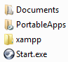When the installation (copy) is complete, your USB drive should now include an **xampp** folder (in addition to the PortableApps folders) in the root folder.
   1. The xampp folder should include a number of subfolders including an htdocs and a mysql folder.
   2. Note the mysql\data folder already includes subfolders. These folders are databases that keep track of your databases. These are why you can’t simply copy database folders into the data folder.
5. Open the xampp folder and then the htdocs folder within it. Delete all the files and folders in the htdocs folder **but not the htdocs folder itself.**
6. Now, you need to test XAMPP. Click the XAMPP Launch menu item in the PortableApps menu. The XAMPP control panel will appear.
7. Click the Start button next to Apache (the web server) and then the Start button next to MySQL (the database server).  
     
   After a little while Apache and MySQL should both turn green. If Apache stays yellow, you’re probably still good to go.  
   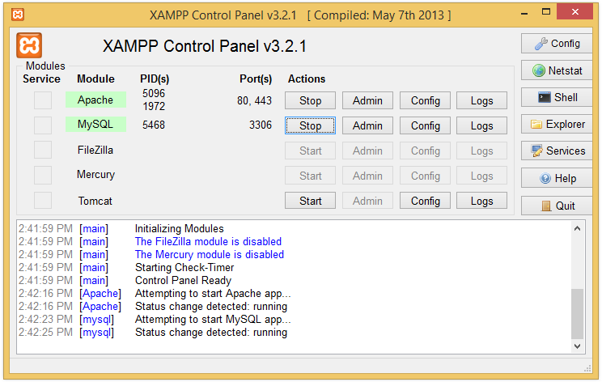
   * Once you’ve started Apache and MySQL, you can **close** this window. Click the X in the upper right corner.  
     
     + This will leave the XAMPP icon in the system tray.  
       
     + If you click the Quit button the system tray icon will also be removed that there’s chance you’ll forget XAMPP is running when you try to eject the USB drive.
     + Minimizing hides the window but shows the icon in the taskbar, making it a little more obvious that XAMPP is still running.
8. If Apache or MySQL fails:
   1. Stop Apache and/or MySQL if they started
   2. Quit XAMPP
   3. Using Windows Explorer locate the setup_xampp.bat file in the xampp folder and double-click (select Yes/OK for any presented options)
   4. Launch XAMPP and start Apache/MySQL again
9. Leave XAMPP running. You’ll need it to test your MySQL installation.

**Installing MySQL**

XAMPP comes with the phpMyAdmin program which allows you to directly control your databases using SQL. This program is also provided by my web server and I’m guessing other web hosting companies provide it as well. However, the phpMyAdmin program is a bit cumbersome to use, so you’ll also learn how to use the MySQL Workbench program.

MySQL Workbench is not designed as a portable application but with a little customizing, we’ll make it work as a portable application

1. Use your browser to navigate to <dev.mysql.com>.
2. Select the Downloads tab
3. Scroll bottom of the page. Select MySQL Workbench.
4. Scroll down near the bottom of the next page. Click the Download button for Windows (x86, 32-bit), MSI Installer
5. Click the No Thanks link at the bottom of the next page unless you want to become a registered MySQL user.
6. Save the installer to your hard drive (that will speed up the installation).
7. Launch the installer.
8. Click the Next button to bypass the welcome screen
9. Click the Change… button in the next dialog box so you can designate your USB drive as the destination
10. Change the folder name (I type it manually) to:  
    pendriveletter:\portableapps\MySQLWorkbenchX  
    (we will remove the “X” later)
11. Click the Next button
12. Choose the Custom button in the next dialog and click Next
13. In the Custom Setup dialog box, deselect the Update Feature (if it’s there) and Program Shortcut options (click each and select the red X)
14. Click the Next button and then click Install
15. After the installation is complete, turn off the Launch MySQL Workbench option (we have more work to do) and click the Finish button.  
    Though you installed the Workbench onto your flash drive, the installation did put files on your host computer. We will now remove those files.
16. Using Windows Explorer (Computer) navigate to the PortableApps folder on your USB drive.
17. Rename the Workbench folder, removing the X from the end of the name.
18. Now we will uninstall the Workbench. But, because we changed the name of the folder on the USB drive, the uninstall program won’t be able to find it, so the folder will remain on your USB drive. The uninstall will remove the files from your host computer though.
19. Double-click the install file you downloaded again (it also includes the uninstall program)
20. Click Next to bypass the Welcome screen
21. Select the Remove option and click the Next button
22. Click Remove
23. Click Finish.  
    Finally, we need to clean up the PortableApps menu.
24. PortableApps adds any file to its menu that has the EXE extension. The Workbench folder includes EXE files we won’t be using. To keep them from showing up on the PortableApps menu, we’ll rename them. (Click Apps, Refresh in the PortableApps menu to see the new EXEs)
25. Using Windows Explorer, add an “x” to the beginning of the **extensions** of the following files in the MySQL Workbench folder (see alternatives below): (tip: sort the files by Type)

* mysql.exe
* mysqldump.exe
* python.exe
* wbadminhelper.exe
* wbcopytables.exe
* Alternative: Instead of renaming the files, you could delete them. I’ve never needed them.
* Better alternative: Right-click the appropriate file (see list above) on your PortableApps menu and choose the Hide option.

1. Your PortableApps menu should now only include the Workbench icon (Apps, Refresh if you need to).
2. To test your MySQL installation, first be sure Apache and MySQL are still running in XAMPP.
3. Click the MySQL Workbench icon in the PortableApps menu. The MySQL Workbench Connections window appears.  
   
4. 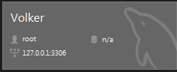Click the + icon to create a new connection.
5. Give the connection a name, any name.
6. Click OK.
7. Click the icon for the connection you just created.
8. Your MySQL Workbench should appear.

**Closing It Down**

1. To close the MySQL Workbench, simply close its window.
2. Before removing your USB drive, you must:

* Stop the Apache server
* Stop the MySQL server

If you don’t, Windows will report that your USB drive is still in use when you try to eject it. Eject your drive properly to prevent Apache and MySQL damage.

1. Open XAMPP (might be in the system tray).
2. Click the Stop button next to Apache
3. Click the Stop button next to MySQL
4. Wait a little to ensure they stay stopped. Every now and then Apache seems to come back to life on its own.
5. Click the QUIT button to completely shut down XAMPP. Closing it (with the x) minimizes it to the tray with no services running.
6. To exit the PortableApps menu, right click it in the tray and choose Exit.
7. You should now be able to eject your USB drive. If not, launch XAMPP again to ensure Apache didn’t come back to life.

**phpMyAdmin Alternative**

As mentioned above phpMyAdmin is an alternative way to test/learn SQL. Actually, it has better export tools than MySQL Workbench. To make phpMyAdmin readily available we have to move it.

1. Copy phpMyAdmin folder from the xampp folder to htdocs
2. To test, using XMAPP launch Apache and MySQL.
3. Open any browser and type *localhost* in the address bar. This will provide a list of folders in the htdocs folder which should include phpMyAdmin. If you see the following screen instead, delete all the files and folders in the htdocs folder **except phpMyAdmin** and try to access localhost again.  
   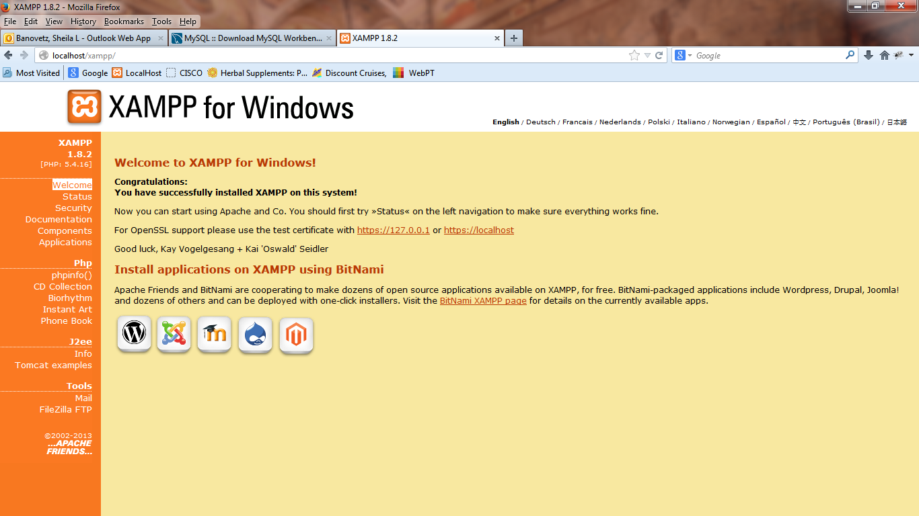

You should NOT see this.

**Hiding the PortableApps Taskbar Icon**

When PortableApps is running, it includes an icon in the Taskbar. If you use PortableApps a lot, that icon takes up space and can be annoying. To hide the Taskbar icon and only show the System tray PortableApps icon:

1. Stop Apache and MySQL (if you haven’t already) and Quit XAMPP. Exit the PortableApps menu.
2. Open \PortableApps\PortableApps.com\Data\PortableAppsMenu.ini (in Notepad)
3. Find [DisplayOptions]
4. Add the command  
   Windows7TaskbarIcon=false (yes, it works in Windows 8)
5. Save the file and relaunch PortableApps. The icon should only appear in the tray, not in the taskbar.