|  |  |  |  |
| --- | --- | --- | --- |
| Name |  | |  |
| Score | / 5 |  |  |
| Update Value | |  |  |
| Make all corrections and resubmit to earn update points | | | |

Systems Implementation

152-172

# Git Overview

5 points

Overview

This lab will give you an overview of the usefulness of Git and an introduction to the Git command line tool.

Remember, your goal here is to get a better understanding of the git program – not to simply complete this lab.

1. Create a Word document to store your Git Journal. Open the document and make journal entries (take notes) as you go through this lab.
2. Visit this site (<http://techcrunch.com/2012/07/14/what-exactly-is-github-anyway/>) to get an overview of GitHub. Read the article; make journal entries as appropriate.
3. 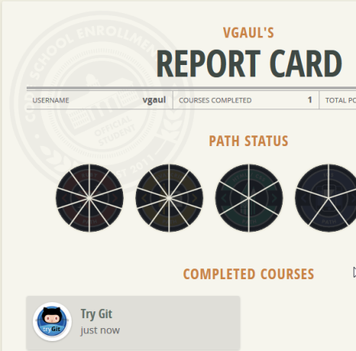Visit this site (<http://try.github.io/levels/1/challenges/1>) to take a “15 minute course” on the basics of the Git command line. Create journal entries as you go.  
     
   I recommend you create an account for later use.  
     
   Tip: Read the advice section (lower right) for each *page* of the course.  
     
   Tip: The progress bar at the top of the page shows you your progress and allows you to return to a previous *page* if you need to.  
   
4. After you’ve completed the course access your Code School profile.Take a screen snapshot that shows you completed course. Crop the screen snapshot to show only your name and completed courses.  
     
   **Paste the screen snap below this line.**

1. Do a search for git on the web. Locate another website that covers Git or GitHub basics. Read over the site and create journal entries.  
   Paste the address below.
2. Email this document AND your journal to me to earn your points.