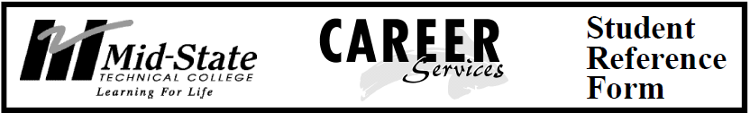

Student Name: Click here to enter text.

Program: Click here to enter text.

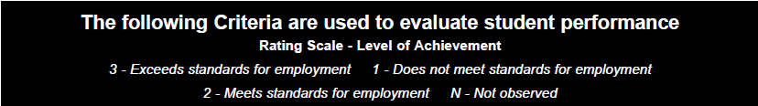

(Type an “X” in the box corresponding to your rating; complete the comments section using complete sentences)

(Insert / remove page breaks where needed)

**Working Productively/Assuring Quality**

|  |  |  |  |  |
| --- | --- | --- | --- | --- |
| Individual possesses and applies effective work habits and attitudes within an organizational (classroom, lab, or shop) setting. | **Rating** | | | |
| **3** | **2** | **1** | **N** |
| 1. Manages time and work load (assignments, projects) |  |  |  |  |
| 2. Follows safety procedures / rules |  |  |  |  |
| 3. Handles responsibility in a dependable manner |  |  |  |  |
| 4. Carries out instructions |  |  |  |  |

Things you do well: **Click here to enter text.**

What you can improve on and how you plan to improve: **Click here to enter text.**

**Learning Effectively**

|  |  |  |  |  |
| --- | --- | --- | --- | --- |
| Individual possesses necessary basic skills in reading, writing, and computing; applies skills in acquiring information; and uses learning tools and strategies. | **Rating** | | | |
| **3** | **2** | **1** | **N** |
| 1. Listens carefully |  |  |  |  |
| 2. Uses learning resources |  |  |  |  |
| 3. Organizes information |  |  |  |  |
| 4. Asks questions |  |  |  |  |

Things you do well: **Click here to enter text.**

What you can improve on and how you plan to improve: **Click here to enter text.**

**Communicating Clearly**

|  |  |  |  |  |
| --- | --- | --- | --- | --- |
| Individual is able to apply appropriate writing, speaking, and listening skills in order to precisely convey information, ideas, and opinions. | **Rating** | | | |
| **3** | **2** | **1** | **N** |
| 1. Applies the English language correctly (spelling, grammar, structure) |  |  |  |  |
| 2. Speaks understandably |  |  |  |  |
| 3. Writes understandably |  |  |  |  |
| 4. Demonstrates ability to listen effectively |  |  |  |  |
| 5. Uses language appropriate to situation |  |  |  |  |

Things you do well: **Click here to enter text.**

What you can improve on and how you plan to improve: **Click here to enter text.**

**Working Cooperatively**

|  |  |  |  |  |
| --- | --- | --- | --- | --- |
| Individual is capable of working with others to complete tasks, solve problems, resolve conflicts, provide information, and offer support. | **Rating** | | | |
| **3** | **2** | **1** | **N** |
| 1. Works cooperatively with others (classroom, shop, practicing) |  |  |  |  |
| 2. Demonstrates respect for others through word and action |  |  |  |  |
| 3. Provides and accepts feedback |  |  |  |  |

Things you do well: **Click here to enter text.**

What you can improve on and how you plan to improve: **Click here to enter text.**

**Acting Responsibly / Acting with Integrity**

|  |  |  |  |  |
| --- | --- | --- | --- | --- |
| Individual recognizes an obligation to self and others for his or her decisions and actions. | **Rating** | | | |
| **3** | **2** | **1** | **N** |
| 1. Attends class regularly and punctually |  |  |  |  |
| 2. Assumes responsibility for completing assignments |  |  |  |  |
| 3. Performs assigned tasks |  |  |  |  |
| 4. Works productively and stays on task |  |  |  |  |

Things you do well: **Click here to enter text.**

What you can improve on and how you plan to improve: **Click here to enter text.**

**Thinking Critically and Creatively**

|  |  |  |  |  |
| --- | --- | --- | --- | --- |
| Individual applies the principles and strategies of purposeful, active, organized thinking. | **Rating** | | | |
| **3** | **2** | **1** | **N** |
| 1. Demonstrates willingness to recognize others’ point of view |  |  |  |  |
| 2. Recognizes the difference between facts and opinions |  |  |  |  |

Things you do well: **Click here to enter text.**

What you can improve on and how you plan to improve: **Click here to enter text.**

**Applying Technology**

|  |  |  |  |  |
| --- | --- | --- | --- | --- |
| Individual uses the principles of science and recognizes the impact of technology. | **Rating** | | | |
| **3** | **2** | **1** | **N** |
| 1. Uses appropriate scientific equipment, methods, and safety procedures |  |  |  |  |
| 2. Demonstrates technological literacy |  |  |  |  |

Things you do well: **Click here to enter text.**

What you can improve on and how you plan to improve: **Click here to enter text.**

**Demonstrating Global Awareness**

|  |  |  |  |  |
| --- | --- | --- | --- | --- |
| Individual demonstrates effective interpersonal and intergroup behaviors in cross-cultural interactions and effective social interaction in a variety of situations. | **Rating** | | | |
| **3** | **2** | **1** | **N** |
| 1. Respects cultural differences |  |  |  |  |
| 2. Communicates in a culturally sensitive manner |  |  |  |  |

Things you do well: **Click here to enter text.**

What you can improve on and how you plan to improve: **Click here to enter text.**

This form is based on the Student Reference Form provided by MSTC Career Services. It has been customized for use in this class.