Relational Database Development

152-156

# Database Design Part 2

20 points

For the Henry Books and Alexamara Marina databases and tables described below, create (for each database):

* ERD that includes table names, key field names, linking field names and relationship cardinalities
* Data Dictionary that includes field names, field types (including max text characters), primary key designations, linking field designations, logical key designations, lookup designations, default values, and validation requirements.
* Use your best judgment and experience to determine logical keys, default values and validation requirements.
* Be sure to list tables in alphabetical order in the data dictionary.
* You may (but don’t have to) work in teams of TWO for this assignment.

Henry Books

Authors

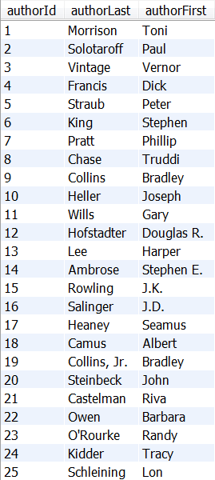

Books

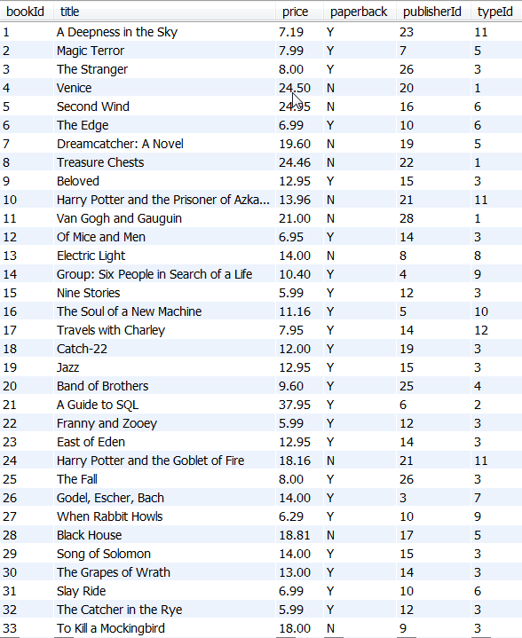

Book Types

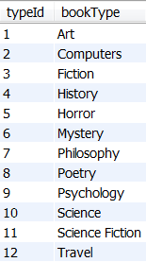

Branches

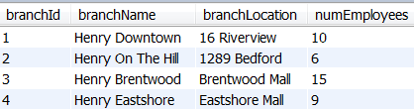

Inventories

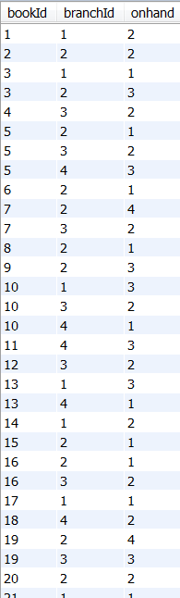33 total records

Publishers

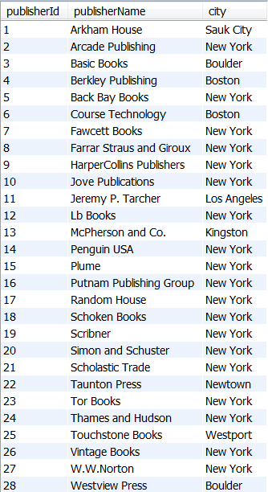

Wrote

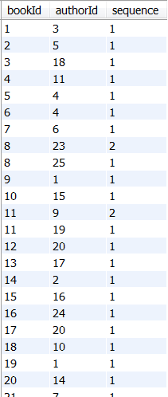33 total records

(continued)

Alexamara Marina

Marinas

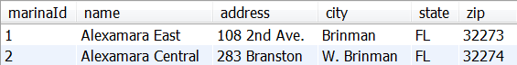

Marina Slips

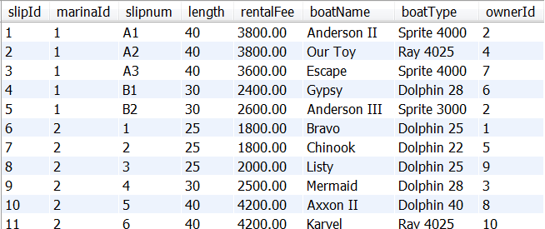

Owners

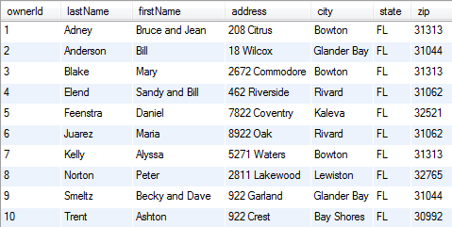

Service Categories

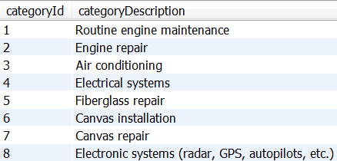

Service Requests

