Relational Database Development

152-156

# Database Design Part 1

10 points

Given the database table information provided below, create:

* ERD that includes table names, key field names, linking field names and relationship cardinalities
* Data Dictionary that includes field names, field types (including max text characters), primary key designations, linking field designations, logical key designations, lookup designations, default values, and validation requirements.
* Use your best judgment and experience to determine logical keys, default values and validation requirements.
* Be sure to list tables in alphabetical order in the data dictionary.
* You may (but don’t have to) work in teams of TWO for this assignment.

Premiere Products

Customers

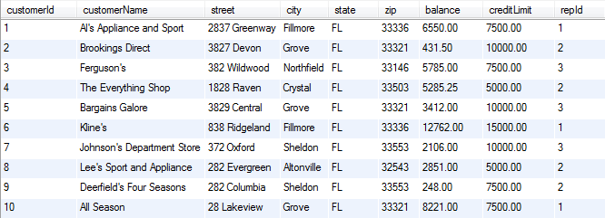

Order Lines

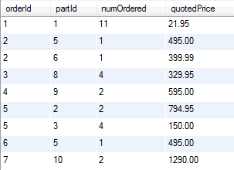

Orders

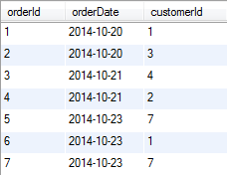

Parts

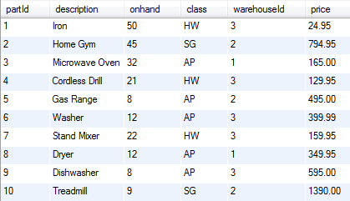

Reps

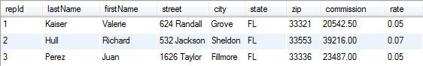

Warehouses

