**Installing Visual Studio 2013**

1. Insert the Visual Studio 2013 DVD into your drive or double-click the file you downloaded from the MSNDAA site to your computer. Setup should begin automatically. If it does not, use (My) Computer to view the contents of the DVD. Double-click the vs_professional.exe file.
2. E:\welcome.tiffWait until the load window goes away.

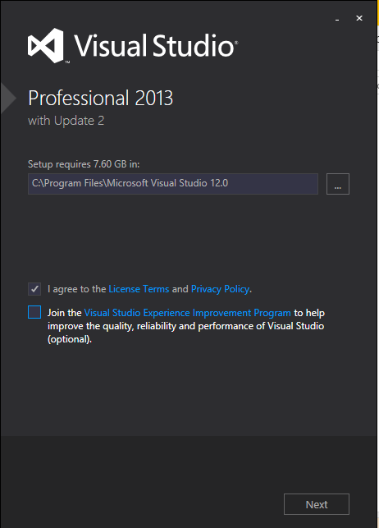

1. In the next window, choose the option to agree to the license terms and conditions. Uncheck the box for the Experience Improvement Program unless you really want to participate. Then, click the Next button.  
     
   Don’t let the 7.6 GB required space scare you—we’ll shrink that in the next step.  
     
     
     
     
   (continued on next page)
2. 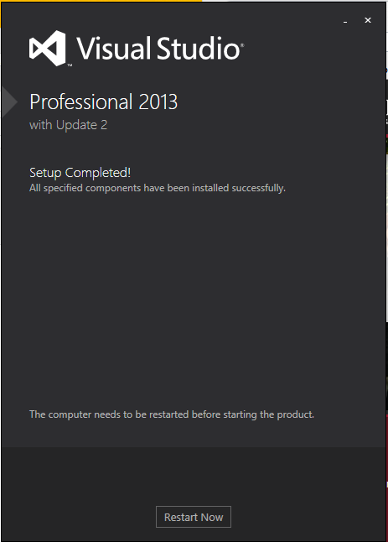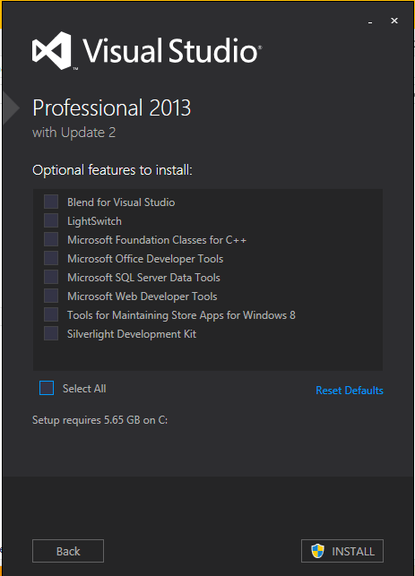The last window allows you to select optional features. We won’t be using any of these so I recommend you save hard drive space on your computer by deselecting all the options. Click the ✓ next to Select All. This will uncheck all the options.  
     
   Note with all the option deselected, Visual Studio 2013 will take 5.65 GB of space on your hard drive.  
     
   If you wish, you may leave any or all of the options selected, but your installation will take up more hard drive space.  
     
   Click the INSTALL button. This installation takes a while.
3. When the installation is complete, you’ll be informed. Click Restart Now to restart the computer and then launch Visual Studio from the Start menu. If you’d rather wait till later, simply close this window.